**Phase-2**

**Student Name:** John Lazarus.L, Rajkumar.M, Karthikeyan.S

**Register Number:** 710423104027, 710423104049, 710423104030

**Institution:** Christ The King Engineering College

**Department:** B.E. Computer Science and Engineering

**Date of Submission:** 10/05/2025

**Github Repository Link:** [Update the project source code to your Github Repository]

# Problem Statement

* + *In the era of content overload, users often struggle to find movies that match their unique preferences, resulting in decision fatigue and a suboptimal viewing experience.*
  + *Traditional recommendation systems frequently rely on generalized trends or basic user data, failing to capture nuanced tastes and contextual factors.*

* + *There is a pressing need for a more intelligent, adaptive solution that can deliver highly personalized movie suggestions.*
  + *This project aims to develop an AI-driven matchmaking system that leverages user behavior, preferences, and contextual data to provide accurate, engaging, and tailored movie recommendations in real-time.*

# Project Objectives

* *Develop an AI Recommendation Engine*

*Design and implement a machine learning model that analyzes user preferences, viewing history, and behavior to generate personalized movie suggestions.*

* *Integrate a Matchmaking System*

*Create a system that aligns user profiles with movie features (e.g., genre, actors, themes, reviews) using natural language processing (NLP) and collaborative filtering.*

* *Enhance User Engagement and Retention*

*Improve user experience through highly relevant recommendations, increasing session time, return visits, and overall platform satisfaction.*

* *Support Real-Time Adaptation*

*Enable the system to adapt recommendations in real-time based on user interactions, feedback, and changing interests.*

* *Ensure Scalability and Performance*

*Build the system to handle large datasets efficiently, ensuring fast and accurate recommendations for millions of users.*

* *Maintain Ethical and Transparent AI Usage*

*Incorporate explainable AI features to make recommendations interpretable and ensure compliance with data privacy regulations.*

# Flowchart of the Project Workflow

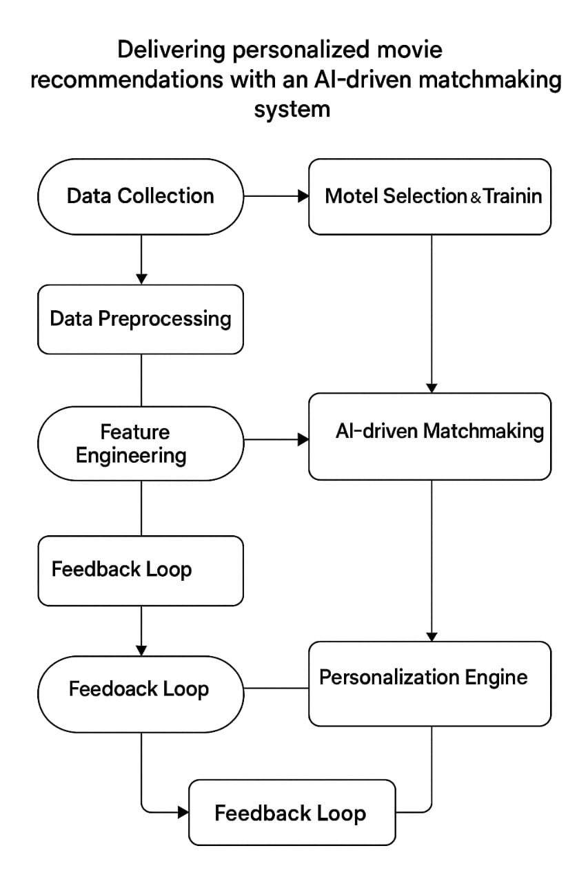

# Data Description

* Movie Metadata
* Title: Name of the movie
* Genres: List of genres (e.g., Action, Drama)
* Director & Cast: Names of key contributors
* Release Year: Year of release
* Duration: Runtime in minutes
* Language: Primary language of the movie
* Tags/Keywords: Descriptive tags (e.g., dystopia, time travel)
* Content Rating: Age classification (e.g., PG-13, R)
* User Data
* User ID: Unique identifier for each user
* Demographics: Age, gender, location (optional for privacy)
* User Preferences: Declared genre, actor, or director preferences
* Watch History: List of previously watched movies
* Ratings/Reviews: User feedback on movies (explicit)
* Browsing Behavior: Clicks, views, skips (implicit signals)
* Interaction Data
* User-Movie Interaction Matrix: Ratings or watch flags in matrix form
* Timestamps: Time and date of interaction
* Watch Duration: How much of the movie was watched
* Interaction Type: Click, view, like, skip, etc.
* External Data (Optional)
* Social Media Trends: What’s popular or being discussed
* Third-Party Reviews: IMDb, Rotten Tomatoes scores
* News & Events: Trending due to awards or anniversaries

# Data Preprocessing

* *Data Cleaning*

*Remove duplicates (e.g., repeated movie entries or user actions)*

*Handle missing values (e.g., fill missing genres or ratings using mean/mode or drop irrelevant rows)*

*Correct inconsistent formats (e.g., date formats, title casing)*

* *Data Transformation*
* *Normalize numeric features (e.g., rating scales, watch time)*
* *Convert timestamps into useful features (e.g., watch time → day/night, weekday/weekend)*
* *Log-transform skewed data (like view counts or popularity scores)*
* *Encoding Categorical Features*
* *One-Hot Encoding: For genres, languages, or ratings*
* *Label Encoding: For ordinal features or identifiers*
* *Multi-label binarization: For multi-genre or multi-tag features*
* *Text Processing (for content-based models)*
* *Tokenize: Break down reviews, descriptions into tokens*
* *Remove stopwords: Eliminate non-informative words*
* *Stemming/Lemmatization: Normalize words to their root form*
* *Vectorization: Convert text into vectors using TF-IDF or embeddings (e.g., Word2Vec, BERT)*
* *Feature Engineering*
* *User preference vectors: Based on watch/rating history*
* *Movie similarity metrics: Cosine similarity, Jaccard, etc.*
* *Interaction weights: Time spent watching, recency of views*
* *Splitting Dataset*
* *Train/Test Split: For model training and evaluation*
* *Cold Start Handling:*
* *For new users: Use demographic or popular movies*
* *For new items: Use metadata-based similarity*

# Exploratory Data Analysis (EDA)

* Understand Dataset Structure

Preview datasets: Inspect top rows of movie metadata, user profiles, and interaction logs

Check dimensions: Number of users, movies, interactions

Data types: Ensure fields like dates and ratings are in appropriate formats

* Movie Data Analysis

Genre distribution: Bar plot of the most common genres

Yearly release trend: Line graph of number of movies released per year

Rating distribution: Histogram of average movie ratings

Top-rated movies: Sort by average rating (with a minimum rating count filter)

* User Data Analysis

User activity distribution: Histogram of number of movies watched per user

Rating behavior: Compare user rating distributions (are users generous or critical?)

User demographics (if available): Age, gender-based preferences

* Interaction Data

Watch frequency over time: Time series of interactions (daily/monthly)

Popular movies: Most watched or rated movies

Heatmap of user-item interactions: Visualize sparsity of the interaction matrix

* Correlation & Similarity

Correlation matrix: Between numeric features like duration, ratings, popularity

Genre co-occurrence matrix: Find commonly paired genres

Movie similarity: Use cosine similarity on TF-IDF vectors or embeddings

* Identify Cold Start & Biases

Movies with few/no interactions: Identify potential cold-start items

Users with limited activity: Flag cold-start users

Popularity bias: Are recommendations skewed toward blockbuster

* Visualizations

Use Seaborn, Matplotlib, or Plotly to create:

Bar charts (genres, user activity)

Histograms (ratings)

Heatmaps (interaction matrix)

Scatter plots (e.g., rating vs. release year)

Word clouds (from movie descriptions or reviews)

# Feature Engineering

* Movie Features

Genre Encoding: Multi-label binarization (e.g., Action=1, Comedy=0, etc.)

Director/Cast Embeddings: Use one-hot encoding or learned embeddings

Release Year Binning: Group years into eras or decades

Content-Based Embeddings:

TF-IDF or BERT vectors from plot summaries, tags, reviews

Latent semantic indexing for topic extraction

* User Features

User Genre Preferences: Aggregate past watched/rated genres

Average Rating Given: Capture rating tendency (harsh vs. generous)

Time of Day Active: Preferred time to watch content

Recency & Frequency: Time since last activity, number of interactions

Embedding of Interaction History: Use collaborative embeddings (e.g., matrix factorization)

* Interaction Features

User-Movie Interaction Matrix: Sparse matrix of ratings or watch flags

Implicit Feedback Features:

Time spent watching

Number of rewatches

Likes/dislikes, skips

Recency Weighting: Time decay for older interactions

User-Item Similarity Score:

Cosine similarity between user and item embeddings

Jaccard similarity of liked genres/tags

* Derived/Composite Features

Hybrid Preference Scores: Combine content-based and collaborative features

Engagement Score: Blend frequency, recency, and duration of user activity

Popularity × Personalization Score: Weighted average of global popularity and personal interest

* Contextual Features (Optional)

Device Type: Mobile vs. desktop preferences

Location: Geo-specific preferences (if ethically gathered)

Time Context: Recommendations tailored to weekends vs. Weekdays

# Model Building

* *Problem Definition*

*Deliver personalized movie recommendations to users based on their preferences, behavior, and profile using AI/ML techniques.*

* *Data Collection*

*Collect and preprocess data from:*

*User Data: demographics, preferences, watch history, ratings*

*Movie Data: genres, actors, directors, release year, ratings*

*Interaction Data: clicks, likes, watch duration*

* *Feature Engineering*

*Extract relevant features:*

*User features: age, gender, location, past viewing behavior*

*Movie features: genre vectors (multi-hot), popularity, release recency*

*Interaction features: user-movie rating, time spent watching*

* *Model Architecture*
* *Collaborative Filtering*

*Matrix Factorization (SVD, ALS)*

*Deep Learning-based: Neural Collaborative Filtering (NCF)*

* *Content-Based Filtering*

*Similarity based on user and movie features (TF-IDF, cosine similarity)*

* *Hybrid Approach*

*Combine collaborative and content-based filtering using ensemble models or meta-learning.*

* *Deep Learning Recommender Systems*

*Deep Neural Networks (DNN)*

*Recurrent Neural Networks (RNN) or Transformers for sequence modeling*

*Embedding layers for categorical variables*

* *AI Matchmaking Layer*

*Reinforcement Learning (e.g., Bandits for dynamic personalization)*

*Knowledge Graphs to capture complex relationships*

*NLP-based analysis on user reviews or descriptions (BERT, GPT)*

* *Model Training*

*Train on historical interaction data*

*Use evaluation metrics: Precision@K, Recall@K, MAP, NDCG*

* *Deployment Pipeline*

*Batch vs. Real-time inference*

*API integration with frontend app*

*Feedback loop for continuous learning*

* *Personalization Layer*

*Context-aware recommendations (time of day, mood, device)*

*User segmentation for tailored models*

# Visualization of Results & Model Insights

* User-Item Interaction Heatmap

Purpose: Show interactions between users and movies (e.g., ratings, clicks).

Description: A heatmap where rows represent users and columns represent movies. Color intensity reflects interaction strength (e.g., rating from 1-5).

Insight: Helps identify patterns in user preferences.

* Recommendation Accuracy Metrics

Charts: Bar or line chart comparing:

Precision@K

Recall@K

F1-Score

NDCG (Normalized Discounted Cumulative Gain)

Insight: Visual comparison of model performance across different algorithms (e.g., collaborative filtering vs. deep learning models).

* Embedding Space Visualization

Tool: t-SNE or PCA projection

Purpose: Show how the model clusters similar users or movies.

Insight: Visualize high-dimensional user/movie embeddings in 2D; similar items are placed closer together.

* Model Comparison Dashboard

Components: Table or bar chart with:

Model name (e.g., Matrix Factorization, Neural CF)

Training time

RMSE/MAE scores

User satisfaction (from A/B test or survey)

Insight: Shows trade-offs between accuracy, performance, and interpretability.

* Personalized Recommendation Examples

Format: For selected user IDs:

Show a list of top-5 recommended movies with genres and a confidence score.

Optionally, add a radar chart for user preferences by genre.

Insight: Demonstrates the model's ability to tailor suggestions per user profile.

* Cold Start Analysis

Chart: Bar chart showing accuracy for:

New users

New items

Frequent users

Insight: Reveals how well the system handles cold-start scenarios.

# Tools and Technologies Used

* Data Collection & Storage

Sources: IMDb, TMDB API, user ratings, watch history, metadata, etc.

Technologies:

Web scraping: BeautifulSoup, Scrapy (for collecting data)

Databases: PostgreSQL, MongoDB, Firebase

Data Lakes: AWS S3, Google Cloud Storage (for large datasets)

* Data Processing & Feature Engineering
* Tools:

Pandas, NumPy: For cleaning and transforming data

Apache Spark: For large-scale processing

* Features:

User behavior (clicks, watch time)

Movie metadata (genres, cast, director)

Text data (descriptions, reviews)

* Recommendation Algorithms
* Content-Based Filtering:

Uses movie metadata + user preferences

TF-IDF, word2vec, BERT for text embeddings

* Collaborative Filtering:

Matrix Factorization (SVD, ALS)

Surprise or LightFM libraries

* Hybrid Models:

Combine content + collaborative signals

Use neural networks (e.g., Neural Collaborative Filtering, Autoencoders)

* Machine Learning & Deep Learning
* Libraries:

Scikit-learn: Traditional ML models

TensorFlow, PyTorch: Deep learning-based recommenders

Hugging Face Transformers: For NLP-based insights

* Personalization Models:

RNNs or Transformers to model user sequences

Reinforcement Learning for dynamic recommendations (e.g., bandit algorithms)

* Deployment & Serving
* Model Serving:

TensorFlow Serving, TorchServe, or ONNX

* APIs:

FastAPI, Flask, or GraphQL for exposing recommendations

* Recommendation Engines:

NVIDIA Merlin, Amazon Personalize, or Google Recommendations AI

* User Interface (Frontend)
* Technologies:

React, Vue.js for interactive UIs

Real-time updates via WebSockets or REST APIs

* Monitoring & Analytics
* Tools:

Prometheus, Grafana: For system monitoring

Google Analytics, Mixpanel: For user interaction tracking

A/B Testing frameworks to compare model performance

# Team Members and Contributions

* *Product Manager*
* *Responsibilities:*

*Define project goals and success metrics*

*Coordinate between stakeholders*

*Prioritize features (e.g., personalization level, UI experience)*

*Oversee A/B testing and user feedback loops*